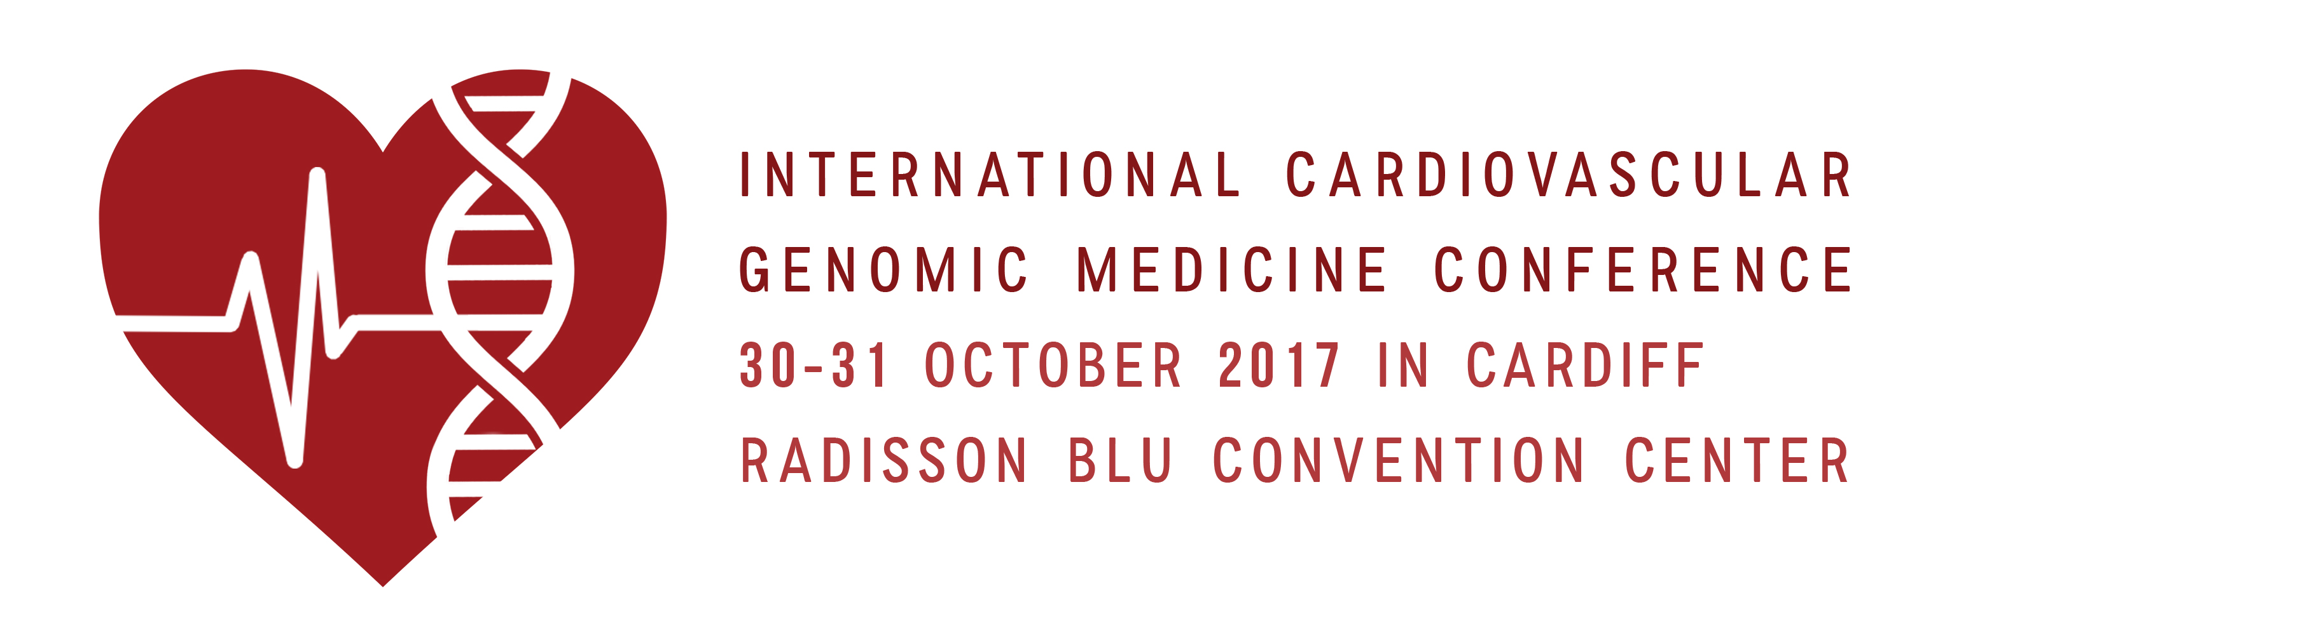
‘INTERNATIONAL CARDIOVASCULAR GENOMIC MEDICINE CONFERENCE’
http://www.genomicmedicine.org/event/international-cardiovascular-genomic-medicine-conference/
30-31 October 2017, RADISON BLU HOTEL, CARDIFF CENTRE, WALES. UK
REGISTRATION FORM

NAME TITLE: Dr/Prof/Ms/Mr

Professional status: Consultant/Senior Academic/Senior Manager/Other (specify)

Institute/Hospital/Organisation:

Address for correspondence:

TEL. Email:

Genomic Medicine Foundation (UK): Non-Member / Member (please give number)

Registration details:

Full package £ 350.00
Day 1 £ 200.00
Day 2 £ 200.00
Gala dinner (30th October) £ 35.00

Total payable £

Terms
- 25% less for GMF-UK Members (www.genomicmedicine.org/membership/)
- 25% Discount for Trainees/ Nurses/ Genetic Counsellors and Laboratory Staff (only for non-GMF-UK members)
- Early bird till 31 August 2017- 15% discount (only for Non GMF-Members)
- Cheques made payable to ‘Genomic Medicine Foundation (UK) Ltd’
- Direct BACS transfer:
Name of Account: The Genomic Medicine Foundation (UK) Ltd.
Sort code: 20-18-15; Account No: 03778304; SWIFTBIC: BARCGB22;
IBAN: GB03BARC20181503778304
- Register direct through Eventsbrite:
https://www.eventbrite.co.uk/e/international-cardiovascular-genomic-medicine-conference-tickets-33330964813
- For Hotel/Accommodation please make reservations through-
https://aws.passkey.com/event/49178888/owner/9557225/home
Please return this form along with cheque/ BACS/ Eventbrite payment reference as email attachment to genomicmedicine@yahoo.co.uk

