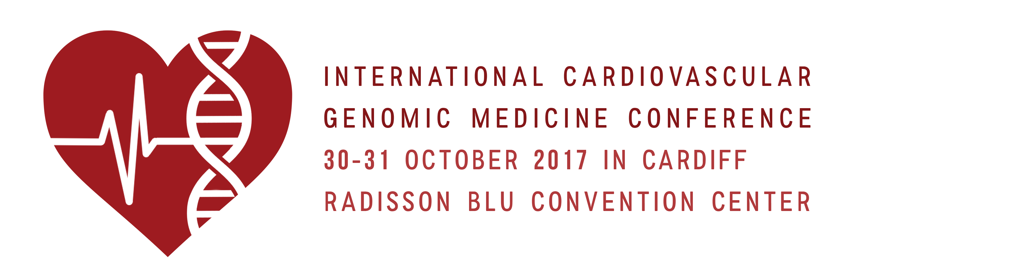
‘INTERNATIONAL CARDIOVASCULAR GENOMIC MEDICINE CONFERENCE’
http://www.genomicmedicine.org/event/international-cardiovascular-genomic-medicine-conference/
30-31 October 2017, RADISON BLU HOTEL, CARDIFF CENTRE, WALES. UK
REGISTRATION FORM

NAME TITLE: Dr/Prof/Ms/Mr

Professional status: Consultant/Senior Academic/Trainee/Genetic Counsellor/ Others

Institute/Hospital/Organisation:

Address for correspondence:

TEL. Email:

Registration details (Discount for Early bird- deadline 15 September 2017)

Senior Medical Staff Trainees/Nurses/Genetic Counsellors/ Clinical Scientists and others
Full package £ 350.00 (300) 262.50 (230)
Day 1 £ 200.00 (150) 150.00 (115)
Day 2 £ 200.00 (150) 150.00 (115)
Gala dinner £ 35.00 26.25

Total £
Total payable £

Terms
- Discount for Trainees/ Nurses/ Genetic Counsellors and Laboratory Staff (see above)
- Early bird discount till 15 Sept. 2017 (see above)
- Cheques made payable to ‘Genomic Medicine Foundation (UK) Ltd’
- Direct BACS transfer:
Name of Account: The Genomic Medicine Foundation (UK) Ltd.
Sort code: 20-18-15; Account No: 03778304; SWIFTBIC: BARCGB22;
IBAN: GB03BARC20181503778304
- For Hotel/Accommodation please make reservations through-
https://aws.passkey.com/event/49178888/owner/9557225/home
Please return this form along with BACS payment reference as email attachment to genomicmedicine@yahoo.co.uk ; Mail cheque/registration form to: Prof. D.Kumar, Institute of Medical Genetics, University Hospital of Wales, Cardiff, CF14 4XW

